Thursday, 10 February 2022

Dear Parent(s)/Carer(s)

Back in December 2019 we first began the process of making amendments to the school uniform and at that time confirmed a school skirt change that we subsequently put on hold when the pandemic took over.

In that time we have also become part of a wider company of schools as Emmaus Multi Academy Company and the Department for Education published new guidance on uniforms in school.

Consequently, and in response to all this, we have decided to amend our uniform from September 2022.

In making these amendments we had the following goals:

1. Reduce the number of compulsory branded items and save families money
2. Procure provision of uniform from two suppliers thus creating competition around price and choice
3. Ensure that uniform is increasingly more sustainable and better for the environment

In making the following changes I am confident that we have done this.

From September 2022 the following uniform changes will apply:

**School Uniform:**

* Blazers will continue to be navy blue, as currently, but all new blazers purchased will include the new school badge. Blazers will be 100% sustainable.
* The school jumper will remain navy-blue and optional, but if, and when, purchased will include the new school badge.
* All girls who choose to wear a skirt for school will need to wear the same skirt. This skirt will only be available from our two selected suppliers and will be compulsory for all from September. Current skirts will not be allowed from September.
* All new starters, both in Year 7 and as in-year admissions, will be expected to wear all of the new compulsory uniform items .
* Students currently on roll will not be expected to change their uniform (with the exception of the skirt) until such time as they have grown out of their current uniform.
* The school tie will change to a navy blue tie for all years and will include the new school badge and a different coloured stripe that will identify each students House. (there will no longer be a KS3 and a KS4 tie)

**PE Kit:**

* The current rugby shirt and white polo will be phased out and replaced by one navy blue polo short with amber lateral panels, this means students will only need one top for PE.
* Plain navy-blue shorts without any branding will remain the compulsory item.
* Leggings and skorts will be navy-blue only, they are an optional alternative item to the shorts, adding the school badge will be optional too.
* Football socks will be navy-blue only.
* An optional PE sweatshirt, with school logo, will also be available from our suppliers.
* A navy-blue base layer/skin will also be an acceptable PE uniform item.

These changes to the PE kit will reduce the number of compulsory items and by moving to plain navy blue skorts and leggings parent(s)/carer(s) will have the choice of buying them from our chosen suppliers or from any high street/online retailer.

Therefore, the new polo top is the only compulsory item that can be solely purchased from our suppliers and with only one top expected to be purchased the cost of PE tops will reduce by half.

The new policy will also remove the expectation that parents purchase two aprons for technology and food. These will instead be provided by school and provide a minimum saving of £16 to parents.

The two chosen suppliers for Hagley Catholic High School for the next 3 years are Hagley Sports and Monkhouse Schoolwear Specialists and we have begun working with them already to realise these new uniform plans in readiness for September.

You can be sure that much more information will come out to you in the very near future and our uniform policy will be updated to reflect these changes from September 2022.

I reiterate all current uniform items, bar the current skirts, can still be worn in September for students in Year 8 to 11 and can be phased out to the new items as new sizes or replacement items are needed.

All new Year 7 students will be expected to wear the new uniform.

At the end of this letter I have included some images of the new skirt, tie and PE top.

Finally, I would remind all parent(s)/carer(s) that if your child is entitled to free school meals financial assistance for uniform is available under our Pupil Premium Promise and information is available on our website about this [here](https://www.hagleyrc.worcs.sch.uk/Files/Download/d4ae815a-c981-41f6-8587-c797a51f7abb/d0297935-5e1b-42ee-82c3-b414dbc41592/PP%20Promise%20Sept%202021.pdf) where you can also find the application form.

Yours sincerely

Mr J Hodgson

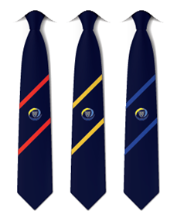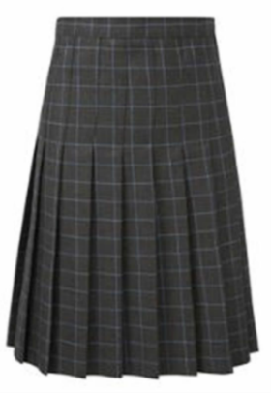*Principal*